**MACHINE LEARNING WITH PYTHON**

What is Machine Learning?

1. Regression, Classifications, Clustering, Scikit-Learn, Scipy
2. Projects: Cancer detection, Predicting economic trends, predicting customer churn, Recommendation engines

Introduction to Machine Learning

1. Clean data, select correct algorithm, train model to understand benign or malignant cells within the data
2. Once trained by going through data iteratively, it can predict the state of the cell with high accuracy
3. “Machine learning is the subfield of computer science that gives computer the ability to learn without being explicitly programmed” – Arthur Samuel
4. Major Machine Learning Techniques
   1. Regression/Estimation: predicting continuous values (e.g. price of house)
   2. Classification: Predicting the item class/category of a case (cell is benign or malignant)
   3. Clustering: Finding the structure of data; summarization (banking)
   4. Associations: Associating frequent co-occurring items/events (grocery items bought together)
   5. Anomaly detection: Discovering abnormal and unusual cases (credit card fraud detection)
   6. Sequence Mining: Predicting next events; click stream (Markhov Model, HMM)
   7. Dimension Reduction: Reducing the size of data (PCA)
   8. Recommendation systems: Associates preferences, recommending items
5. A.I: Tries to make computers intelligent, in order to make computers intelligent:
   1. Computer vision
   2. Language processing
   3. Creativity
6. Machine Learning: Branch of AI that covers the statistical side of AI
   1. Classification
   2. Clustering
   3. Neural Network
7. Deep Learning: Revolution in ML:
   1. Field of Machine Learning where computers can learn and make decisions on their own

Python for Machine Learning

Python libraries for machine learning

1. Numpy: Math library to work with N dimensional arrays
   1. Enables computation efficient and effectively
   2. Arrays, dictionaries, functions and data types
2. Scipy: Collection of numerical algorithms and domain specific toolboxes
   1. Signal processing, optimization, statistics
   2. Scientific and high-performance computation
3. Matplotlib: Plotting package that provides 2-D plotting and 3-D plotting
4. Pandas: High-level library, high-performance, easy to use data structures
   1. Many functions for data importing, manipulation and analysis
   2. Data structures and operations for manipulating numerical tables and time series
5. Scikit-Learn: Collection of algorithms and machine learning

Scikit-Learn

1. Free software machine learning library
2. Classification, Regression and Clustering algorithms
3. Works with NumPy and SciPy
4. Great documentation
5. Easy to implement

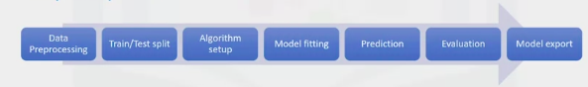

1. Provides utility functions to change raw feature vectors into suitable vector for modeling
2. Split the data into train and test sets
3. Set up the algorithm (clf)
4. Train the model by passing the training set to the fit method
5. Use the metrics to run prediction
6. Confusion matrix to show the results
7. Save the model

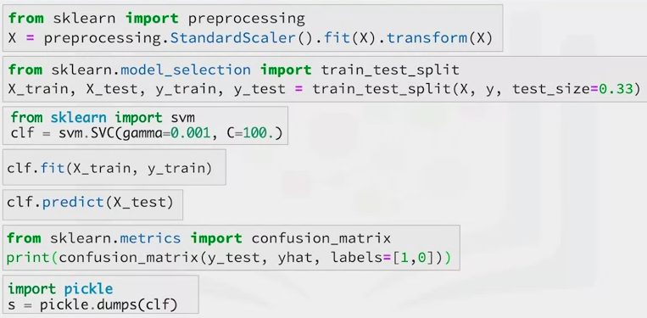

Supervised and Unsupervised Learning

Supervised

1. Teach the model, then with that knowledge, it can predict unknown or future instances
2. Teach the model from a labeled data set
   1. Attributes
   2. Columns: features
   3. Rows: Observation
3. Two kinds of data
   1. Numerical
   2. Categorical
4. Two types of supervised learning techniques
   1. Classification: Process of predicting discrete class labels or categories
   2. Regression: Process of predicting continuous values

Unsupervised Learning

1. The model works on its own to discover information
2. The unsupervised algorithm works on an unlabeled data set and unlabeled data
3. Unsupervised Learning Techniques
   1. Dimension reduction/feature selection
   2. Density estimation: Used to explore data to find structure within it
   3. Market basket analysis: Modeling technique that if you buy a certain group of items you are more likely to buy another group of items
   4. Clustering: Grouping data point or objects that are somehow similar
      1. Discover structure
      2. Summarization
      3. Anomaly detection

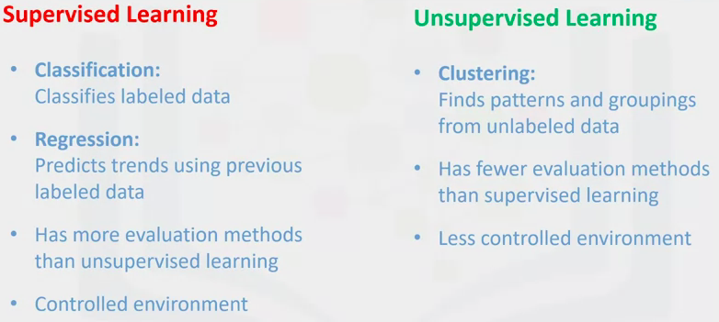

Introduction to Regression

1. Process of predicting a continuous value using other variables
   1. Dependent variable: State, target or final goal trying to predict (y)
   2. Independent variable: Causes of this states (x)
2. What is a regression model?
   1. Simple regression: One independent variable is used to estimate a dependent variable.
      1. Simple linear regression
      2. Simple non-linear regression
   2. Multiple regression:
      1. Multiple linear regression
      2. Multiple non-linear regression
3. Applications of regression
   1. Sales forecasting
   2. Satisfaction analysis
   3. Price estimation
   4. Employment income

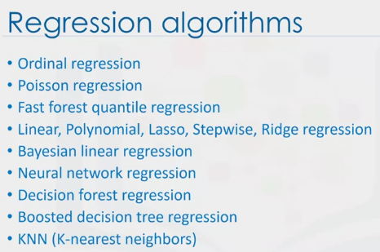

Simple Linear Regression

1. Fitting line is shown as a polynomial

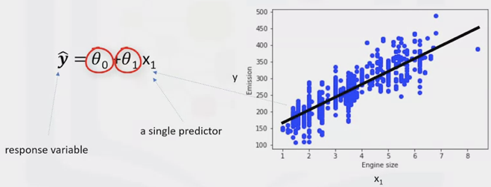

1. Theta 1: Slope or gradient
2. Theta 0: Intercept
   1. Called the coefficients of the linear equation

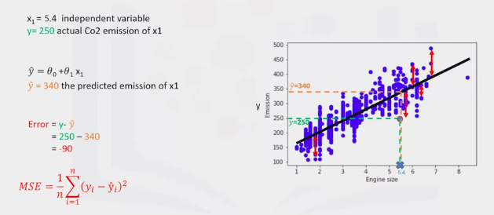

1. Mean Square Error (residual error): Objective is to find the line where all the errors are minimized. Error is the distance from the data point to the fitted regression line.
2. The mean error of the prediction using the fit line should be minimize
3. How should we best find Theta 1 and Theta 0
   1. Mathematical approach:

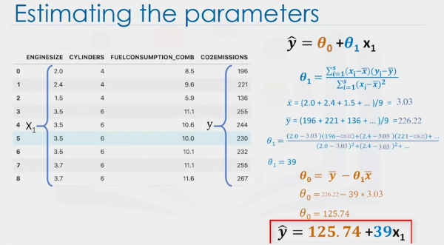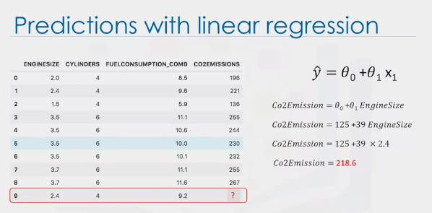

* + 1. Theta0 (bias coefficient) Theta1 (coefficient for the co2 emission column)
  1. Optimization approach:

1. Useful because:
   1. Very fast
   2. No parameter tuning
   3. Easy to understand and highly interpretable

Model Evaluation

Train and Test

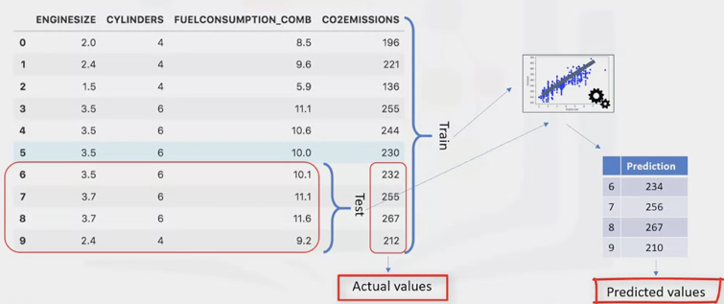

* 1. Train the model on the entire dataset and then test the model using a portion of the same dataset

1. Training Accuracy: percentage of correct predictions the model makes when using the test dataset
   1. High training accuracy isn’t always a good thing
   2. Result of over-fitting
      1. Overly fit: the model is overly trained to the dataset, which may capture noise and produce a non-generalized model
2. Out-of-sample Accuracy: Percentage of correct predictions the model makes on data it has not been trained on
   1. Important that models have a high, out-of-sample accuracy
   2. How to improve out-of-sample accuracy?

Train/Test Split: splitting the datasets respectively, which are mutually exclusive

* 1. Train with the training set and test with the testing set

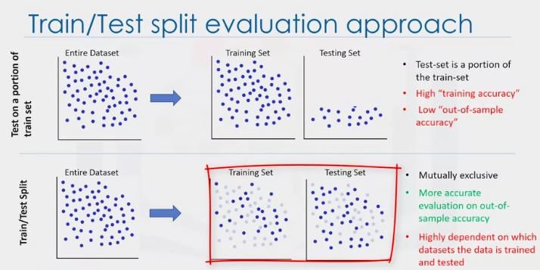

1. The testing data is not part of training data used to train the model
2. We know the outcome of each data point in the data set. The model has no knowledge of the outcome of the data points
3. Ensure you train the model with the testing set afterwards, you don’t want to lose potentially valuable data

K-Fold Cross Validation

1. How to fix a high variation that results from a dependency? You average it

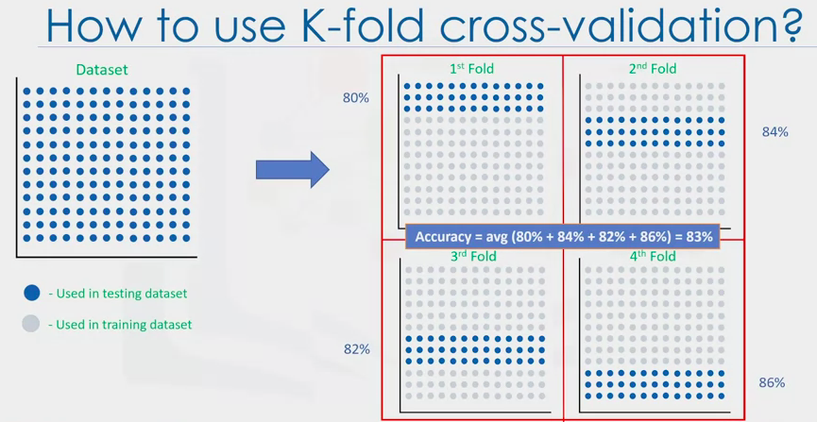

1. K = 4 folds
   1. First 25% for training, the rest for testing
   2. Second 25% used for training, the rest for test
   3. No training data used in one fold is used in another

Evaluation Metrics in Regression Models

1. The error of the model is the difference between the data points and the trend line generated by the algorithm
2. Mean Absolute Error: Mean of the absolute value of the errors
3. Mean Squared Error: Mean of the squared error
   1. More popular as the focus is geared towards large errors
4. Root Mean Squared Error: Square root of the mean squared error
   1. Interpretable in the same units as the response vector – making it easy to relate its information
5. Relative Absolute Error (Residual sum of Square): Takes the total absolute error and normalizes it by dividing it by the total absolute error of the simple predictor
6. Relative Squared Error: Similar to relative absolute error, but is widely adopted as it is used for calculating R^2

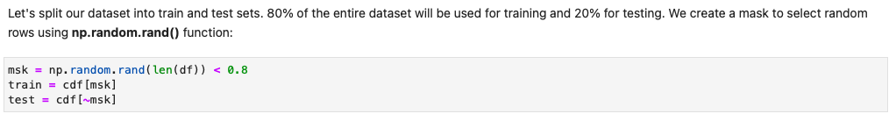

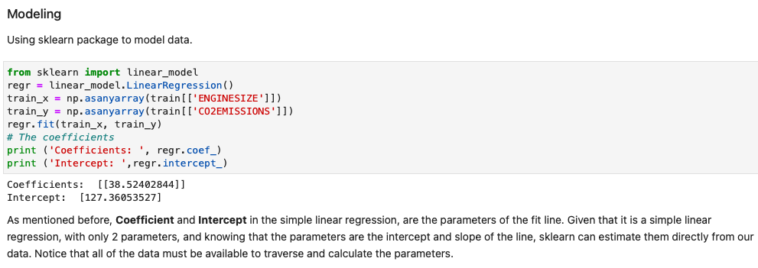

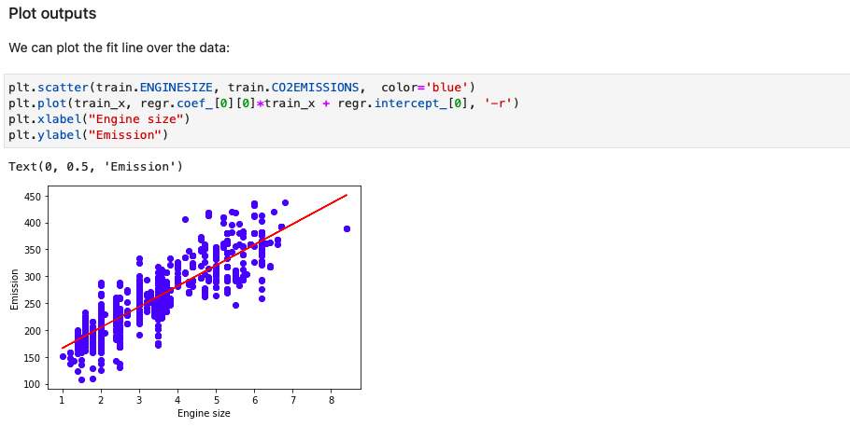

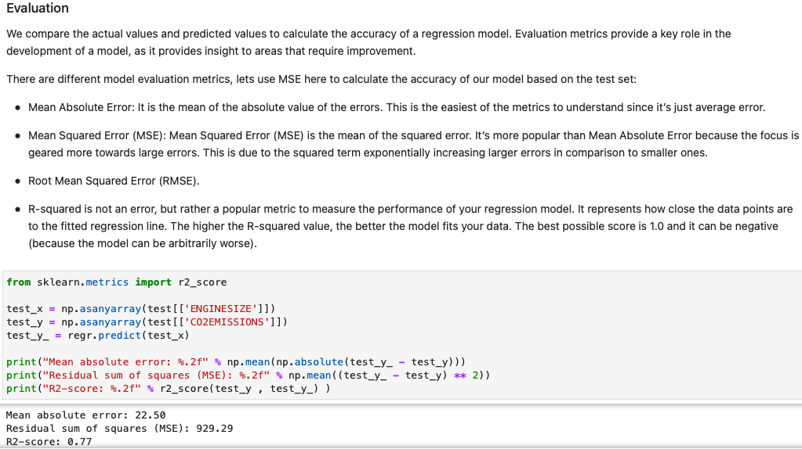

Multiple Linear Regression

Applications for Multiple Linear Regression

1. Independent variables effectiveness on prediction
   1. Identify the strength of the effect of the independent variable on a dependent variable
   2. Does revision time, test, anxiety, lecture attendance and gender have any effect on the exam performance of students?
2. Predict the impact of changes
   1. Understand how the dependent variable changes when we change the independent variables
   2. How much does blood pressure go up (or down) for every unit increase (or decrease) in the BMI of a patient?

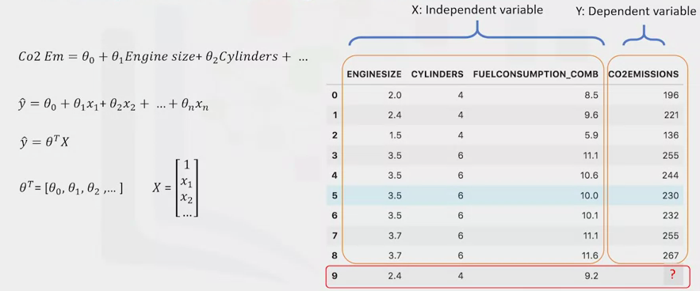

1. X = feature set
   1. First element set to 1 because it turns the theta0 into the intercept or bias parameter, when the vector is multiplied by the parameter vector
2. Theta -T-X = in a one dimensional space is the equation of a line, it is what is used in simple linear regression. In higher dimensions, where we have more than one input (x), it is called a plane or a hyperplane.
   1. This is what is used for multiple linear regression. The goal is to find the best fit hyperplane for our data
   2. We should estimate the values for Theta vector that best predict the value of the target field in each row
   3. Minimize the error of the prediction

Optimized Parameters

1. Optimized parameters are parameters that lead to the model with the fewest errors
2. How to estimate Theta
   1. Ordinary Least Squares: Tries to estimate the values of the coefficients by minimizing the mean square error
      1. Linear algebra operations
      2. Takes a long time for calculating matrixes (for less than 10000 you can use this approach
   2. An optimization algorithm: Process of optimizing the values of the coefficients by iteratively minimizing the error of the model on your training data
      1. Gradient descent: Starts optimization with random values for each coefficient. Then calculates the errors and tries to minimize it through “y’s” changing of the coefficients in multiple iterations.
      2. Proper approach if you have a very large dataset

Prediction Phase

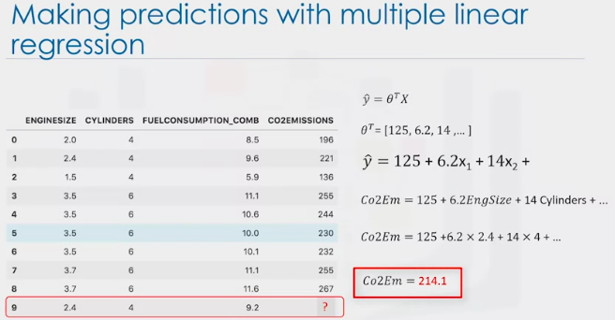

Q & A

1. Adding too many independent variables, without any theoretical justification, may result in an over-fit model
2. Should independent variables be continuous?
   1. Categorical independent variables can be converted into a model by converting them into variables
      1. Car type (0 = manual / 1 = automatic)

Non-Linear Regression

* + - 1. Especial estimation method of the non-linear regression method
      2. Estimate the parameters of the model (Theta’s) and predict the model for future relationships

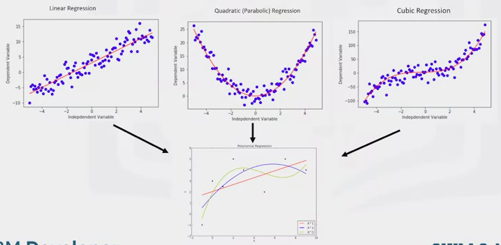All of these are polynomial regression. Where the relationship between the independent variable (X) and the dependent variable (Y) is modeled as an Nth degree polynomial in X.

Polynomial Regression

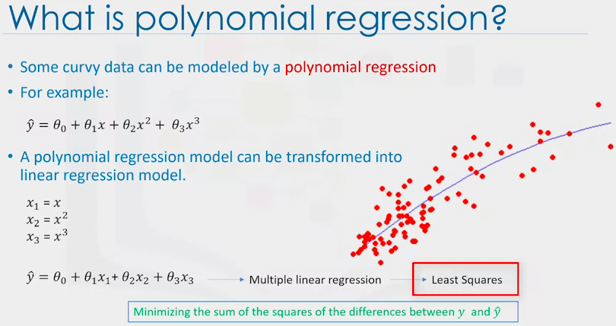  
What is Non-Linear Regression?

1. A method to model non-linear relationship between the dependent variable and a set of independent variables
2. Y(hat) must be a non-linear function of the parameters Theta, not necessarily the features X
3. When it comes to non-linear equation, it can be the shape of exponential, logarithmic and logistic
4. In non-linear regression a model is non-linear by parameters
5. In linear-regression we cannot use the ordinary least-squares method to fit the data

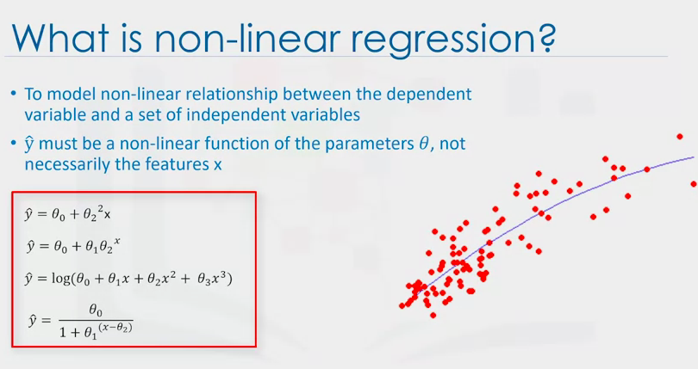

Linear vs Non-Linear Regression

1. How can you know if a problem is linear or non-linear?
   1. Inspect visually: Plot by bivariate plots of output variables with each input variable.
      1. Calculate the correlation coefficient between independent and dependent variables. If for all variables it is 0.7 or higher there is a linear tendency
   2. Based on accuracy: Use non-linear regression instead of linear regression
2. How should I model my data, if it displays non-linear on a scatter plot?
   1. Polynomial regression
   2. Non-linear regression model
   3. Transform your data

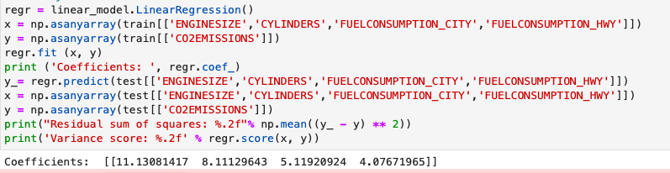

Week 3 Classification

Introduction

1. Supervised learning approach
2. Categorizing some unknown items into a discrete set of categories or classes
3. Attempts to learn the relationship between a set of feature variables and the target variable in question
4. The target attribute is a categorical variable with discreet values
5. Classification determines the class label for an unlabeled test case
6. Business applications
   1. Which category a customer belongs to
   2. Whether a customer witches to another provider/brand
   3. Whether a customer responds to a particular advertising campaign
7. Several applications – many problems can be expressed as associations between feature and target variables

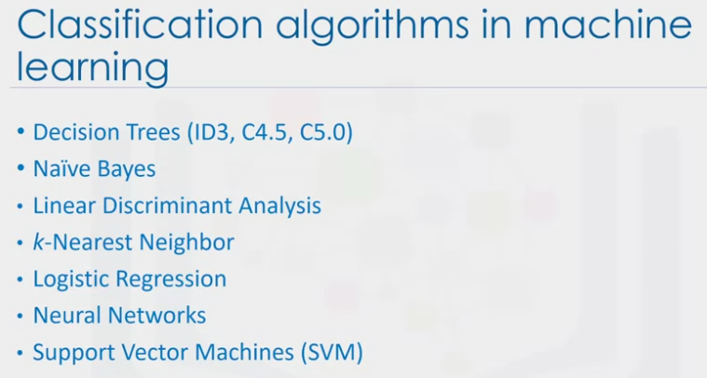

K-Nearest Neighbors

1. Goal is to build a classification model for a new or unknown case

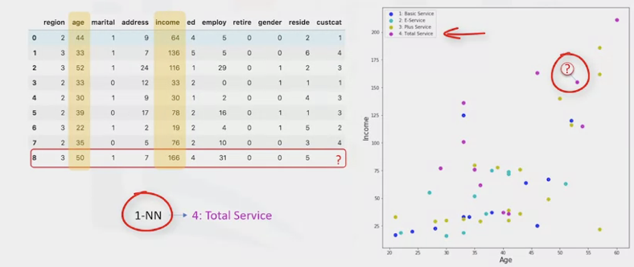

1. To what extent can we trust the prediction
   1. Especially if it is a poor example or an outlier

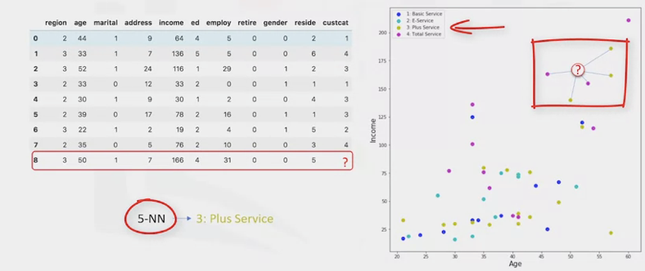Using 5 of the nearest neighbors provides a more accurate prediction

1. Method for classifying cases based on their similarity to other cases
2. Similar cases with the same class labels are near each other – the distance between two cases is a measure of their dissimilarity

K-Nearest Neighbor Algorithm

1. Pick a value for K
2. Calculate the distance of the unknown case from all cases
3. Select the K-observations in the training data that are nearest to the unknown data point
4. Predict the response of the unknown data point using the most popular response value from the K-nearest neighbors

Calculating the Similarity/Distance in a 1-dimensional space  
 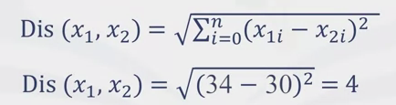Assuming age in the only information

Calculating the Similarity/Distance in a 2-dimensional space

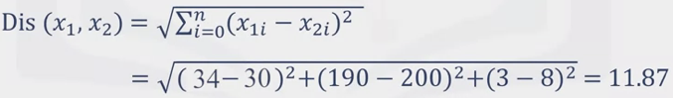Assuming age and income

What is the best value of K for KNN?

1. Reserve part of the data for testing the accuracy of the model
2. Then choose K=1 and use the training part for modeling using all samples in the test set
3. Increase the K, repeating the process, until the best accuracy is achieved

Evaluation Metrics in Classification

1. Jaccard Index
   1. The size of the intersection divided by the size of the union by two labeled sets

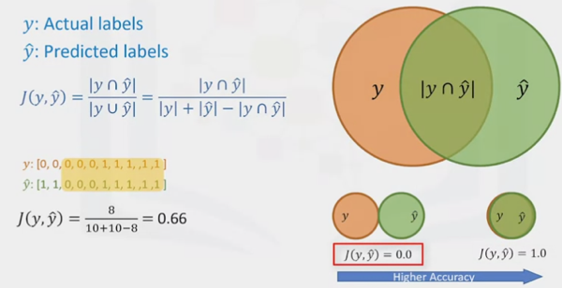

1. F1-Score
   1. Confusion Matrix

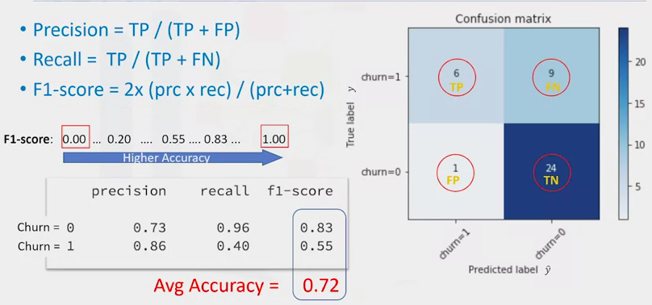

1. Log Loss
   1. Log loss measures how far each prediction from the actual label
   2. Then calculate the average log loss across all rows of the test set

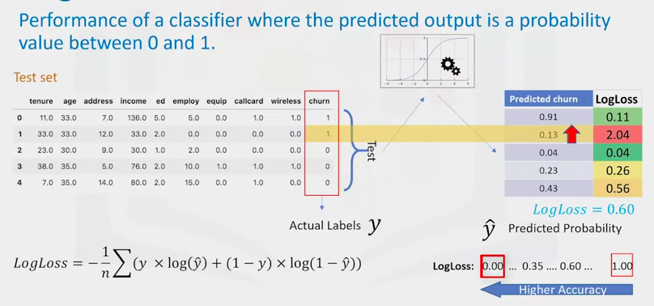

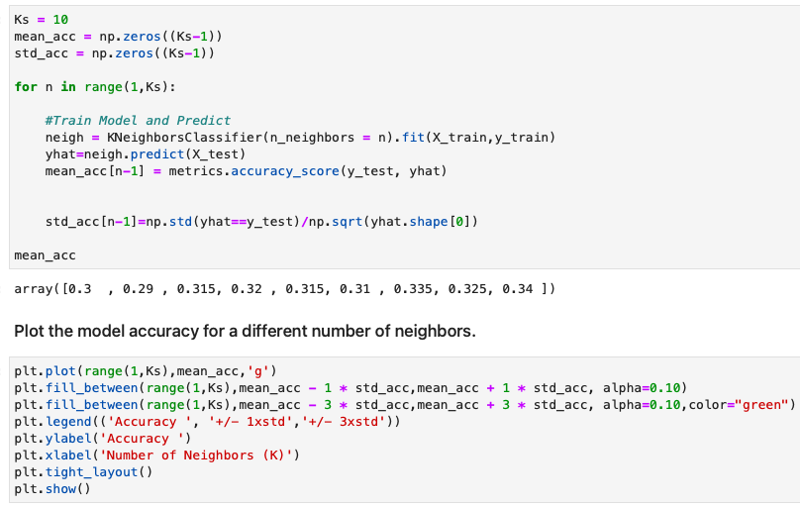

Decision Trees

1. Built by splitting the training set into distinct nodes
   1. One node contains most of, or all of, one category of the data
2. Testing an attribute and branching the cases, depending on the result of the test
   1. Each internal node corresponds to a test
   2. Each branch corresponds to a result of the test
   3. Each leaf node assigns a patient to a class

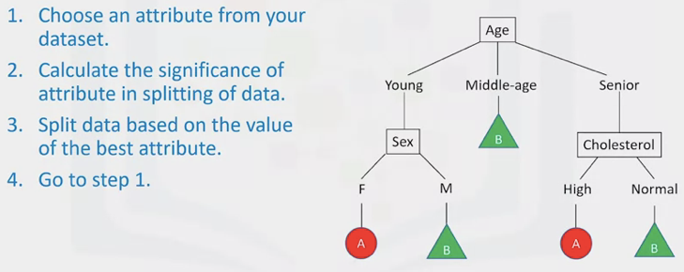

Building Decision Trees

1. Built using recursive partitioning to classify the data
2. Predictiveness – less impurity – lower entropy
3. Choice of attribute to split data is crucial – it is all about purity of the leaves after the split
4. Pure node: 100% of the nodes fall into a specific category of the target field
5. Impurity of nodes is calculated by entropy of data in the node

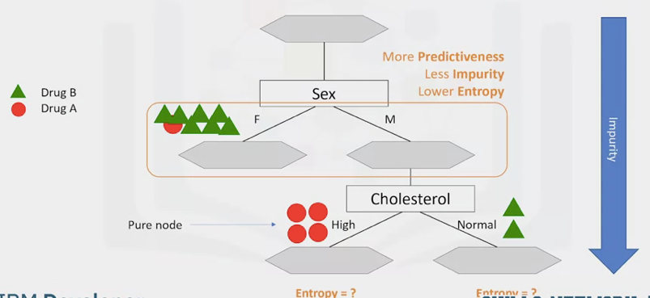

1. Entropy is the amount of information disorder (or randomness/uncertainty)
2. The entropy is used to calculate the homogeneity of the samples in that node
   1. If the samples are completely homogeneous the entropy is 0
   2. If the samples are equally divided it has an entropy of 1

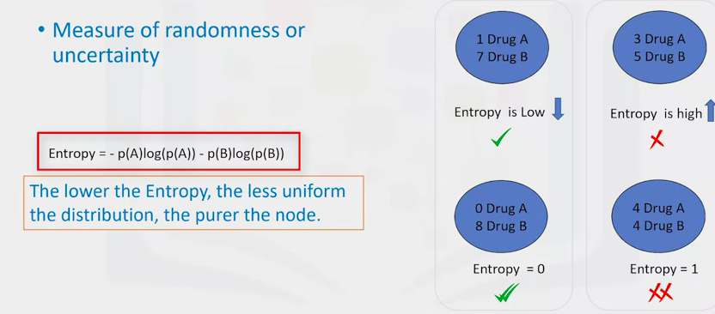

The libraries used will calculate the entropy for you

1. Go through all the attributes after the split and select the one with the least entropy

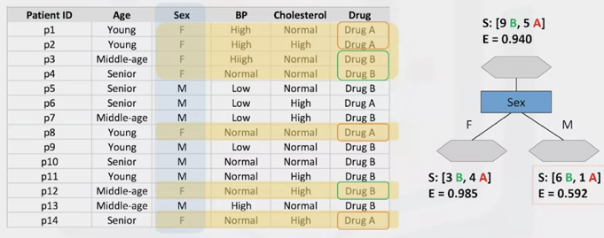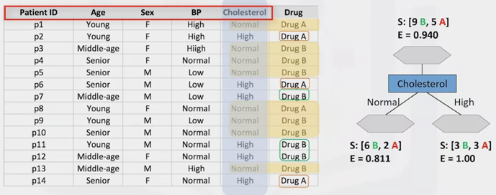

1. The tree selected will be the one with the highest information gain after splitting
2. Information gain: information that can increase the level of certainty after splitting
   1. I.G. = (entropy before split) – (weighted entropy after split)
3. Information gain and entropy are opposites
   1. As the weighted entropy decreases the information gain increases

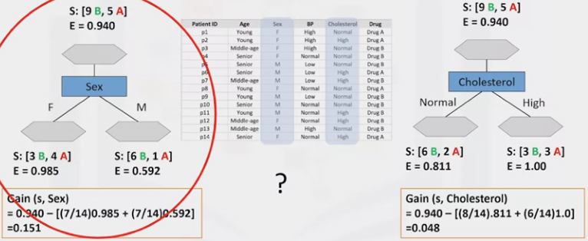

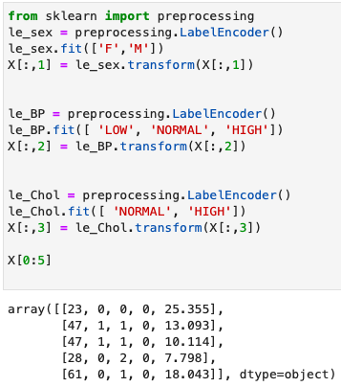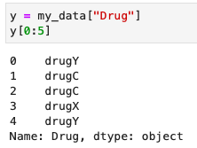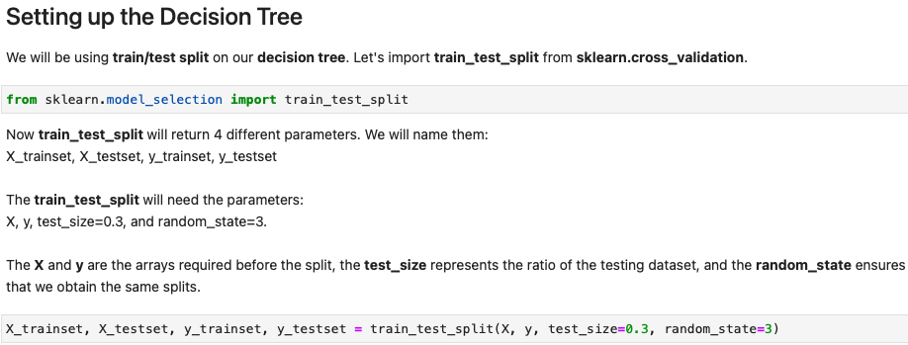

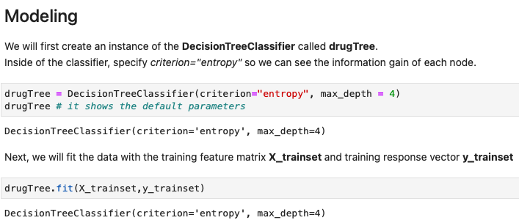

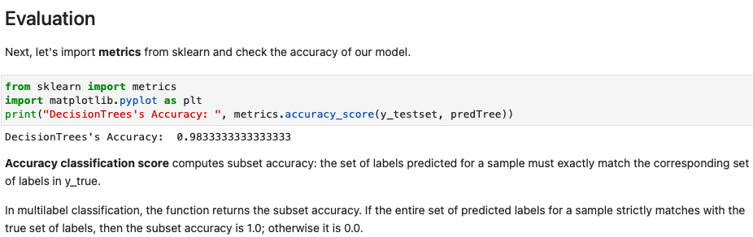

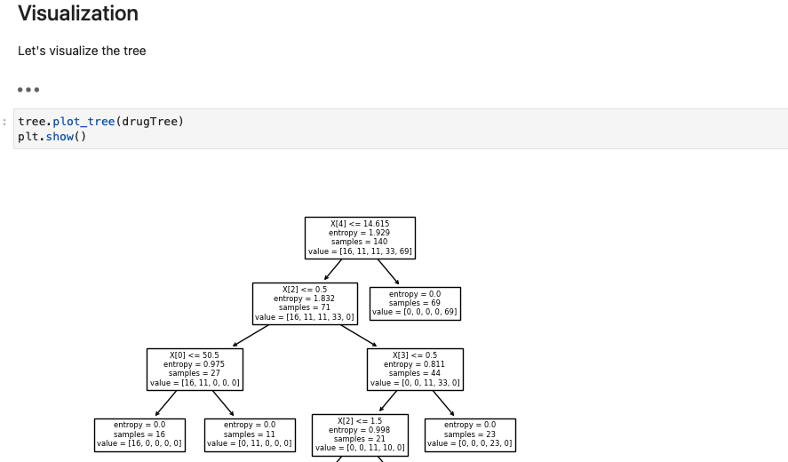

Logistic Regression

1. Statistical and machine learning technique for classifying records of a dataset based on the values of the input fields
   1. It is a classification algorithm for categorical variables
2. Analogous to linear regression but tries to predict a categorical or discreet target instead of a numerical one
   1. Binary predictor (yes/no) – coded as 0/1
   2. Independent variables should be continuous
   3. If categorical they should be dummy or indicator coded
   4. Can be used for both binary and multi-class classification

Applications of Logistic Regression

1. Predicting the probability of a person having a heart attack (given age, sex, etc)
2. Predicting the mortality in injured persons
3. Predicting a customer’s propensity to purchase a product or halt a subscription
4. Predicting the probability of failure of a given process or product
5. Predicting the likelihood of a homeowner defaulting on a mortgage

When is Logistic Regression Suitable

1. If your data is binary 0/1, yes/no, true/false
2. If you need probability results
   1. Returns a probability score between 0-1
3. When you need a linear decision boundary (line, plane or hyperplane)
4. If you need to understand the impact of a feature
   1. Feature X with a theta1 close to 0 has a smaller effect than a feature with large absolute impact

Logistic Regression vs Linear Regression

1. Logistic regression gives the probability of a value falling in a class
2. Using sigmoid function, gives us the probability of a point belonging to a class instead of ‘Y’ directly
   1. Will always return a value of between 0-1

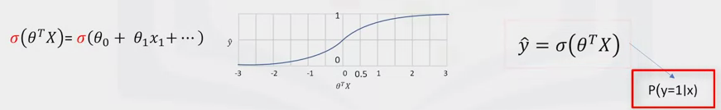

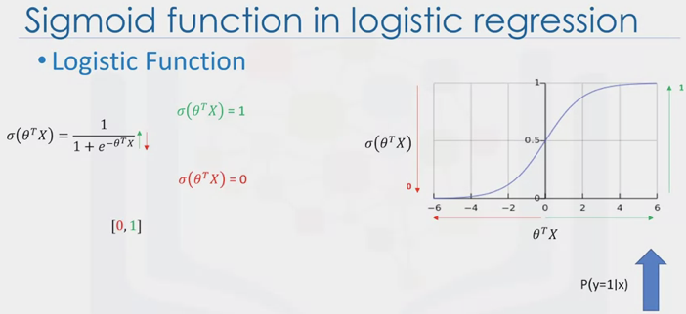

What is the output of the model?

1. P(Y=1|X) : probability the input (x) belongs to the default class (Y=1)
2. P(Y=0|X) = 1 – P(Y=1|X)
3. P(Churn = 1|income,age) = 0.8
4. P(Churn = 0|income,age) = 1 – 0.8 = 0.2
5. The job is to train the model to set its parameters values that the model is a good estimate of probability of Y = 1 given X

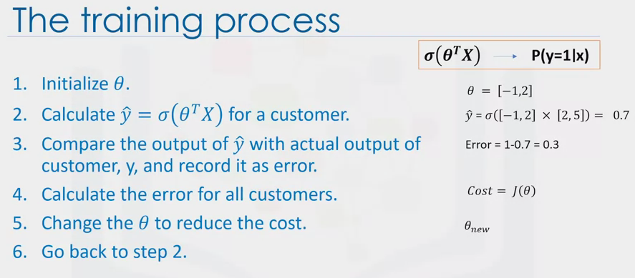

1. Initialize theta value with random values
2. Calculate the model output for a random customer in your training set. X (in thetatransposeX) is the feature vector values (age, income, etc). Theta is the confidence or weight in the previous step
3. The difference is the model’s error for a specific customer.
4. Calculate for all customers and add up these errors (Cost = J(Theta))
   1. Show how poorly the model is estimating the customer’s labels
   2. The lower the cost, the better the model is
5. Change values of Theta

Use gradient descent to change theta

Logistic Regression Training

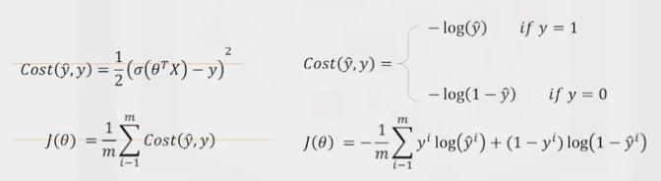

1. Minimize the cost function
2. How to minimize the cot function?
   1. Using gradient descent
3. Gradient descent: A technique to us the derivative of a cost function to change the parameter values, in order to minimize the cost

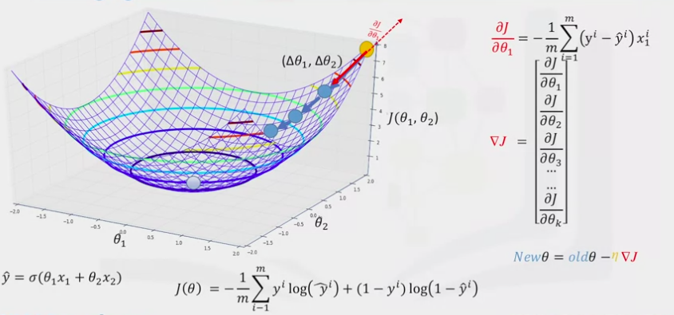

1. Minimize cost function J (function of variables theta1 and 2)
2. Find the best parameter values… find the minimum value of the cost by changing the parameters
3. You change the parameters by delta theta1, delta theta 2
4. To find how to update the parameters you should calculate the gradient of the cost function at that point
5. The gradient is the slope of the surface at every point. And the direction of the gradient is the direction of the greatest uphill
6. How to calculate the gradient of a cost function at a point?
   1. Gradient descent takes increasingly smaller steps to the minimum with each iteration
7. The given equation calculate the gradients
   1. The equation returns the slope of that point and we should update the parameter in the opposite direction

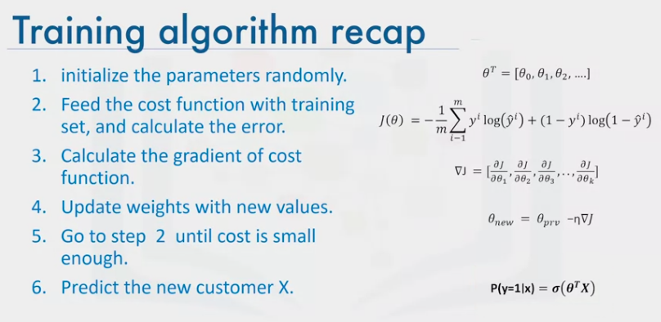

Support Vector Machine (SVM

1. Supervised algorithm that classifies cases by finding a separator
   1. Mapping data to a high-dimensional feature space
   2. Finding a separator
   3. Separator drawn as a hyperplane

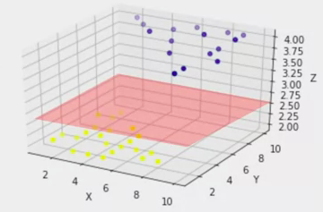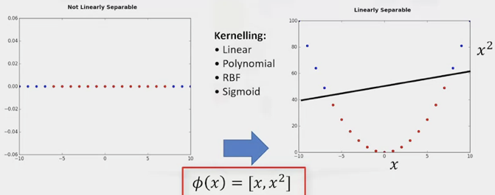

1. Kernaling: Mapping data into a 3-D environment
2. Best hyperplane has the largest margin possible

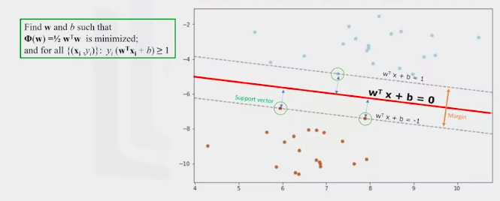

1. Advantages
   1. Accurate in high-dimensional spaces
   2. Memory efficient
2. Disadvantages
   1. Prone to over-fitting
   2. No probability estimation
   3. Small datasets (more than 1000 rows)
3. Applications
   1. Image recognition
   2. Text category assignment (text mining)
   3. Detecting spam, text category assignment, sentiment analysis
   4. Gene expression classification
   5. Regression, outlier detection and clustering

**MACHINE LEARNING WITH PYTHON – WEEK 4**

1. Segmentation is the practice of partitioning a customer base into a group of individuals that have similar characteristics
2. Analytical approach for large datasets

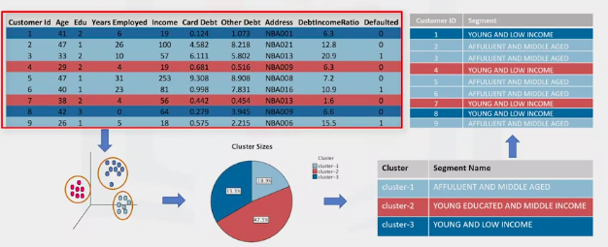

1. Clustering: finding clusters in a data set unsupervised
2. Develop highly personalized experience for the client
3. Classification: Predict categorical class labels. Defining instances to predefined classes e.g.
   1. Decision tree, SVM or logistic regression
   2. Supervised learning where each training instance belongs to a class
4. Clustering: Unlabeled and unsupervised
   1. K-means, etc

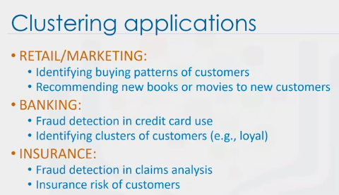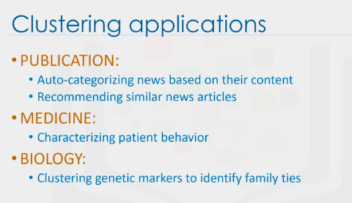

* 1. Exploratory data analysis
  2. Summerary generation
  3. Outlier detection
  4. Pre-procesing steps
  5. Finding duplicates

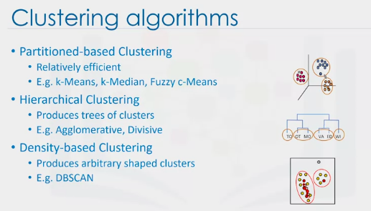

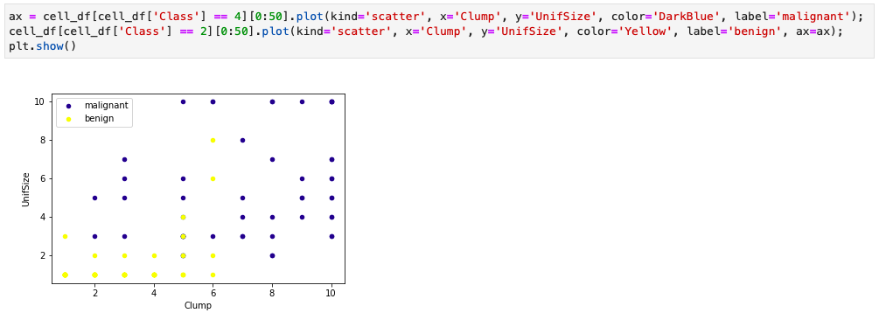

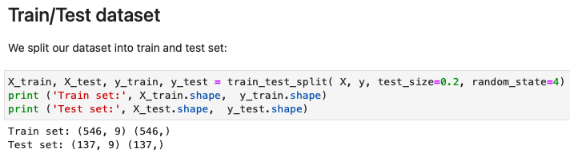

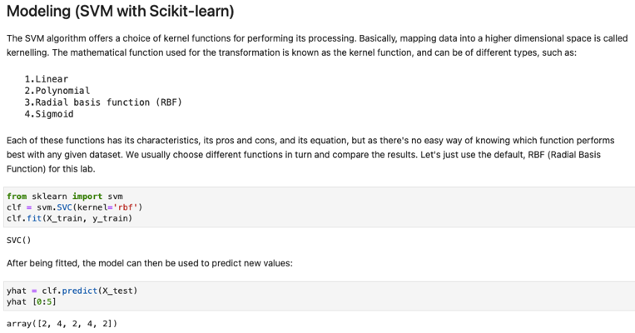

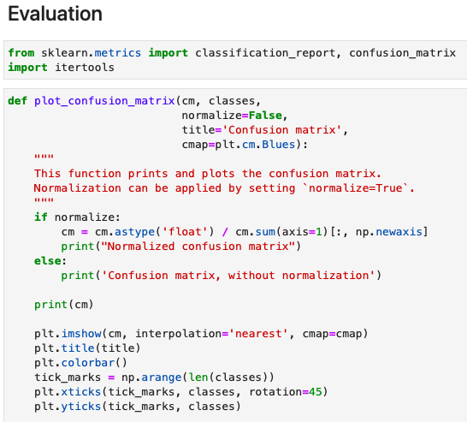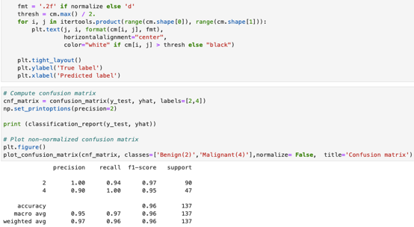

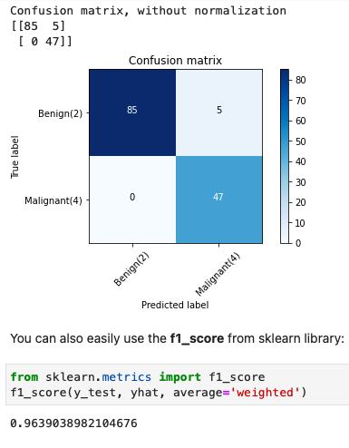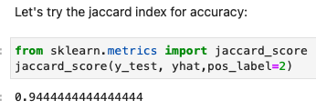

Intro to k-Means

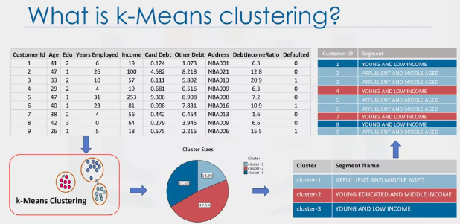

1. Group data only un supervised
2. Partitioning clustering: divides data into non-overlapping subsets without any cluster internal structure
3. Dissimilarity metrics
   1. Intra-cluster distances minimized
   2. Inter-cluster distances maximized

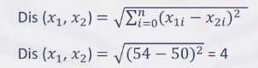Uclidian distance

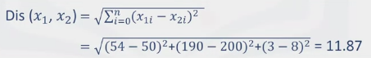Multiple-dimensional

Steps of K-means

1. Initialize K centroids randomly
   1. Either pick three data points as random centroids
   2. Pick three points at random and assign them as centroids
2. Distance matrix is created
3. Assign each point to the closest centroid
4. The average centroid of each cluster becomes the main centroid
   1. Points are reclustered and new centroized created till the process is complete

K-Means Accuracy

1. Randomly placing k Centroids, one for each cluster
2. Calculate the distance of each point from each centroid – uclidian distance
   1. Other types, not just uclidian distance, can be used
3. Assign each data point (object) to its closest centroid, creating a cluster
4. Recalculate the position of the K centroids
5. Repeat till centroids no longer move

Accuracy

1. External approach
   1. Compare the clusters with the ground truth, if it is available
2. Internal Approach
   1. Average the distance between data points within a cluster

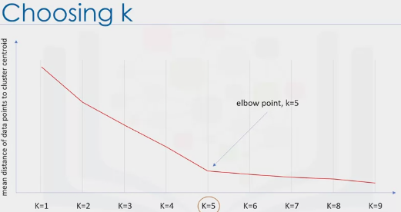

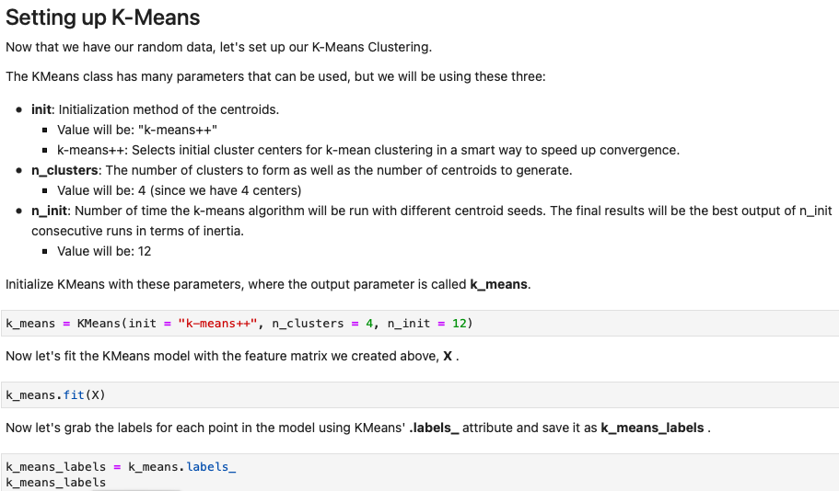

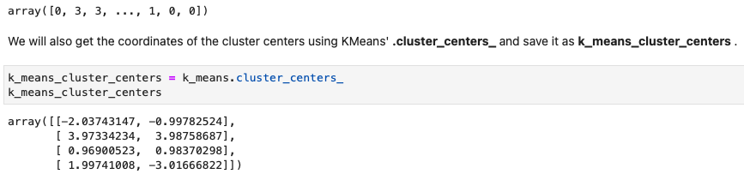

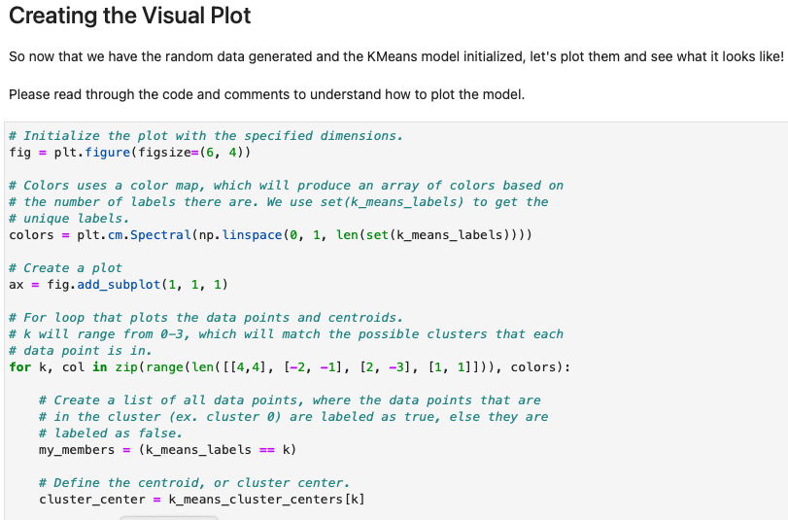

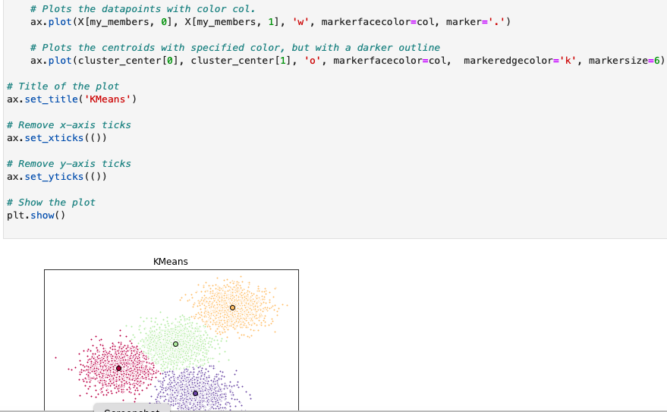

Hierarchical Clustering

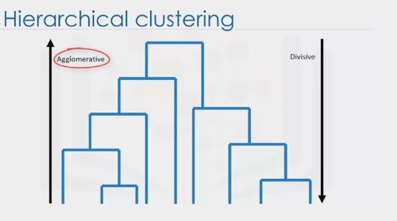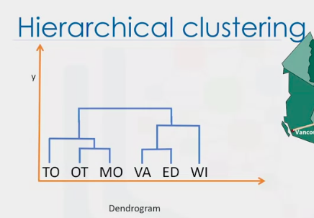

1. Agglormerative Algorithm
   1. Create *n* clusters, one for each data point
   2. Compute the Proximity matrix (n, by, n table)
   3. Repeat
      1. Merge the two closest clusters
      2. Update the proximity matrix
   4. Until only a single cluster remains
2. Use different criteria
   1. Data type
   2. Dimensionality
   3. Domain knowledge

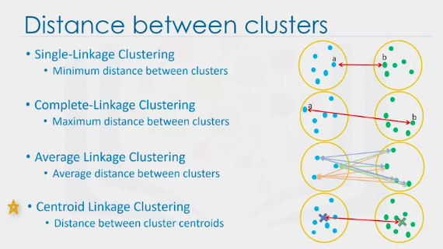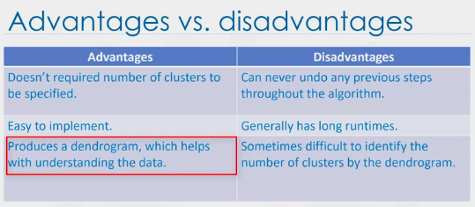

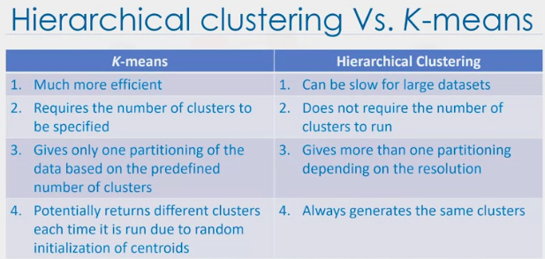

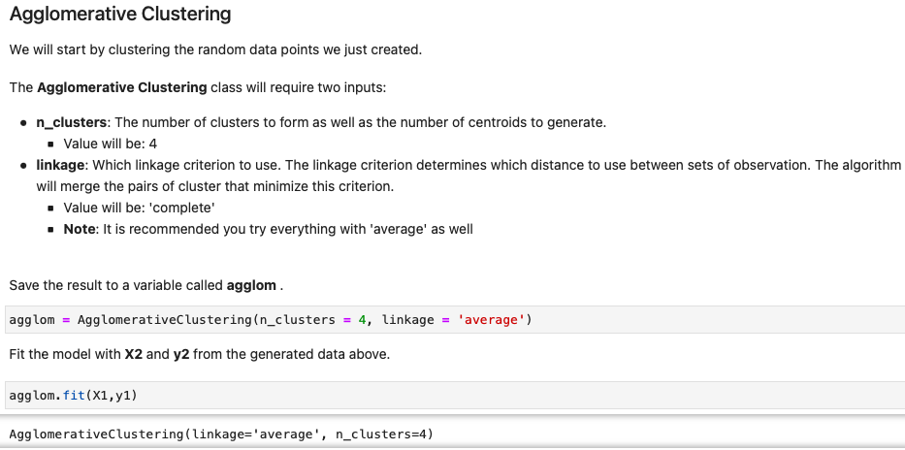

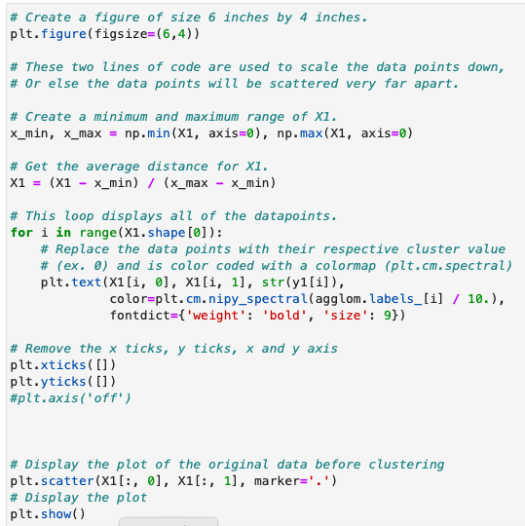

DBSCAN

1. Density: Number of data points within a radius
2. Class identification on a spatial context
3. Find any arbitrary spaced cluster without getting effected by noise
   1. Can find the denser part of data samples by ignoring less dense areas or noises
4. Density Based Spatial Clustering of Applications with Noise
   1. One of the more common algorithms
   2. Works based on density objects
5. R (Radius of Neighbor)
   1. Radius that, if it includes enough number of points within it, we call it a dense area
6. M (min number of neighbors)
   1. The minimum number of data points we want in a neighborhood to define a cluster

How DBSCAN Works

1. Core data points: There are at least M points
2. Border point: Less than M points or it is reachable from a core point

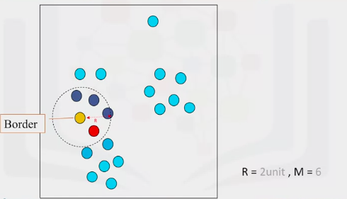

1. Outlier: Not a core point or close enough to be a border point
2. Connect core points that are neighbors
   1. One core point
   2. All reachable core points
   3. All their borders

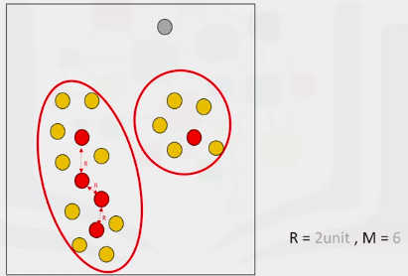

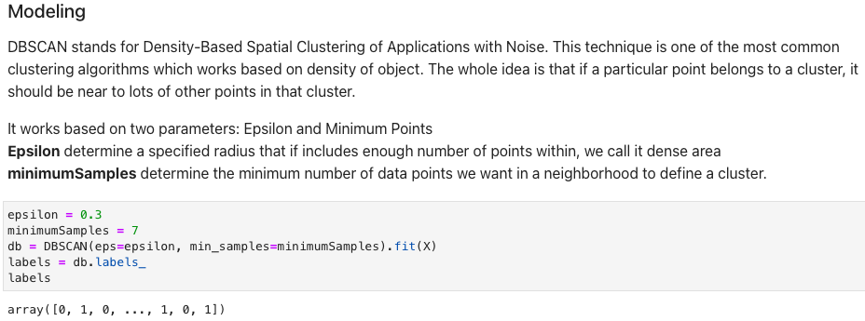

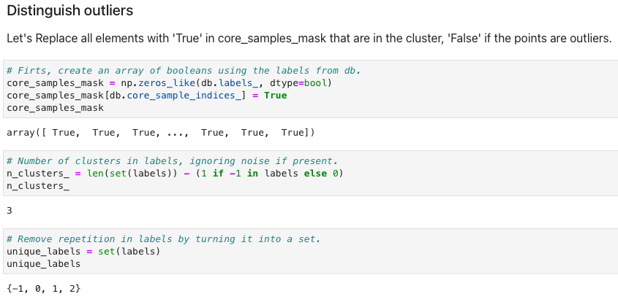

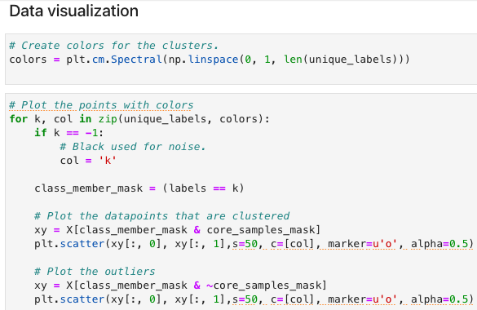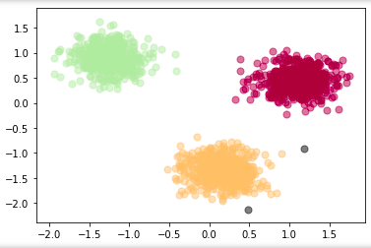

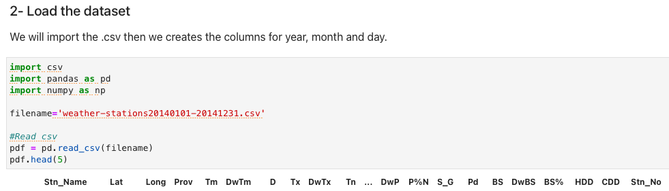

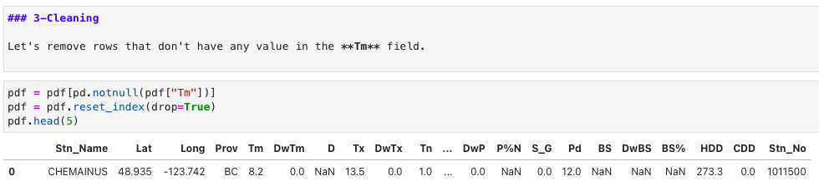

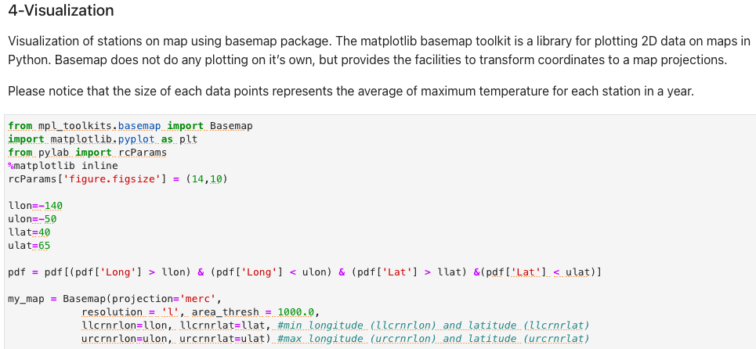

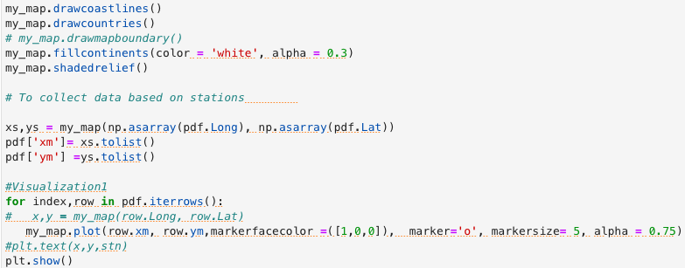

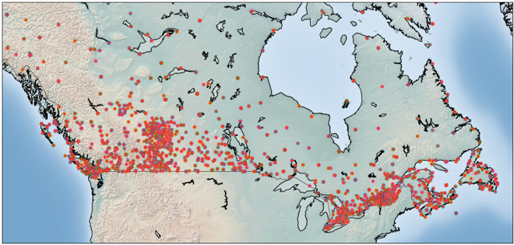

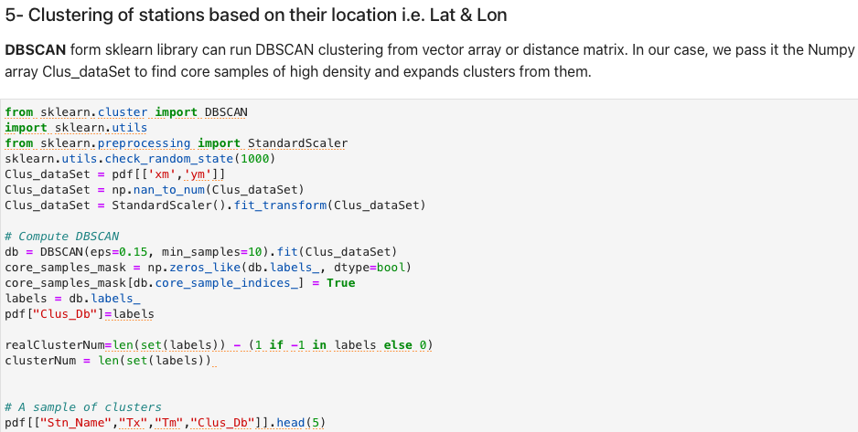

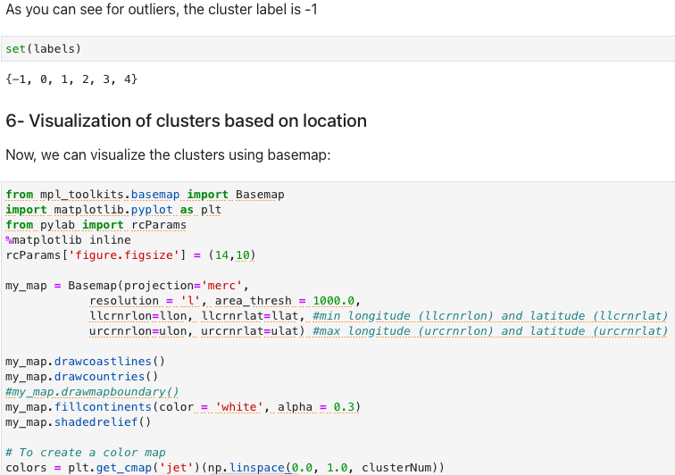

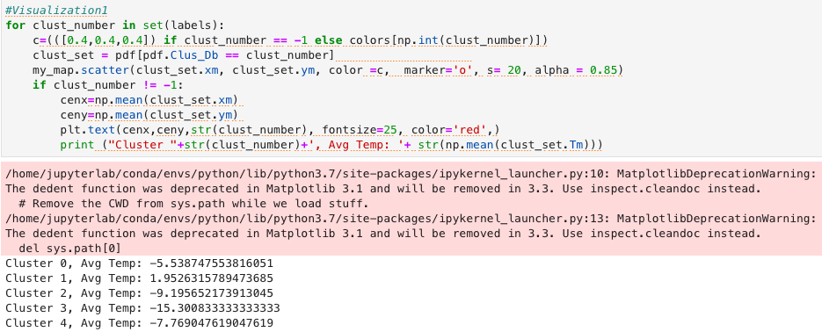

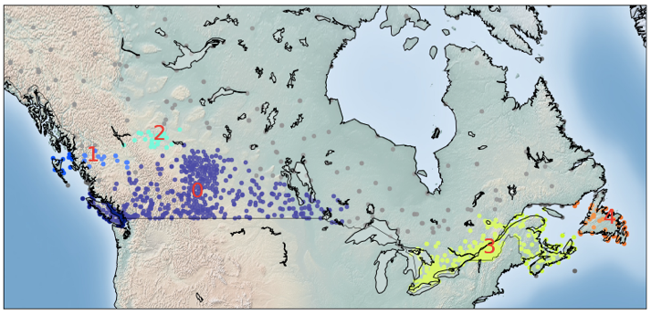

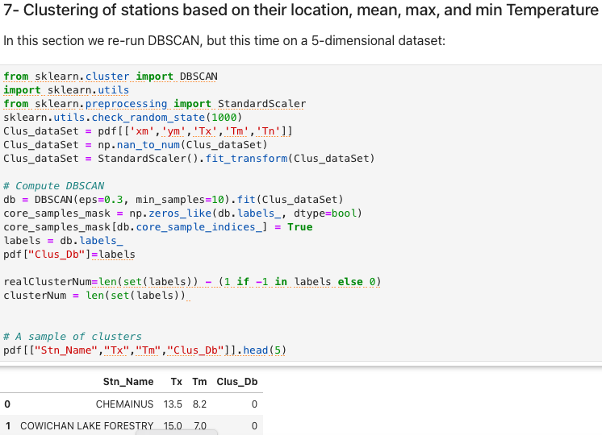

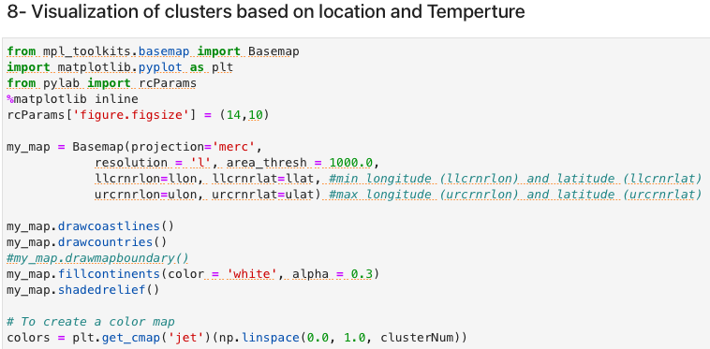

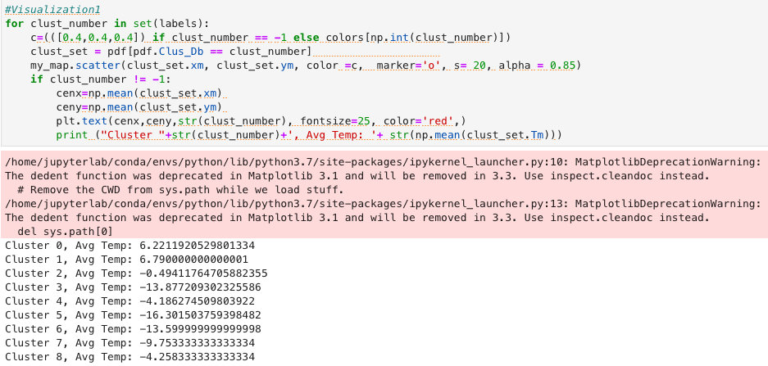

CONTENT-BASED RECOMMENDATION ENGINES

1. Recommender systems capture the pattern of people’s behavior and use it to predict what else they might want or like – including who they are friends with
2. Broader exposure
3. Possibility of continual usage or purchase of the products
4. Procedures better experience
5. Content based: “Show me more of what I have liked before
6. Collaborative filtering: “Tell me what is popular among my neighbors
7. Memory Based:
   1. Uses entire user-item dataset to generate a recommendation
   2. Uses statistical techniques to approximate users or items (pearson correlations, Euclidian etc,)
8. Model-Based:
   1. Develops model of users in an attempt to learn their preferences
   2. Models an be created using machine learning techniques like regression, clustering, classification

Content-Based Recommender Systems

1. Recommends items to users based on their profiles. Theirs profiles revolves around their preferences and tastes. Based on users tastes based on the. Number of times the user has clicked on or liked those items
2. Based on similarity.
   1. Content: Category, tag, genre

Collaborative Filtering

1. User-based collaborative filtering
   1. Based on the users’ neighborhood
   2. Active user
   3. Looks for users’ that are similar
   4. History, preference and choices
2. Item-based collaborative filtering
   1. Based on items’ similarity
3. Step 1: Similarity weighting
   1. Create a similarity weighting between the active user and other users
4. Step 2: Weighted ratings matrix
   1. Multiple the similarity weights by the users’ ratings
   2. Results in the weighted ratings matrix
5. Step 3: Create a recommendation matrix by aggregating all of the rated weights
   1. Normalize the weighted rating values by dividing the sum of the similarity for users

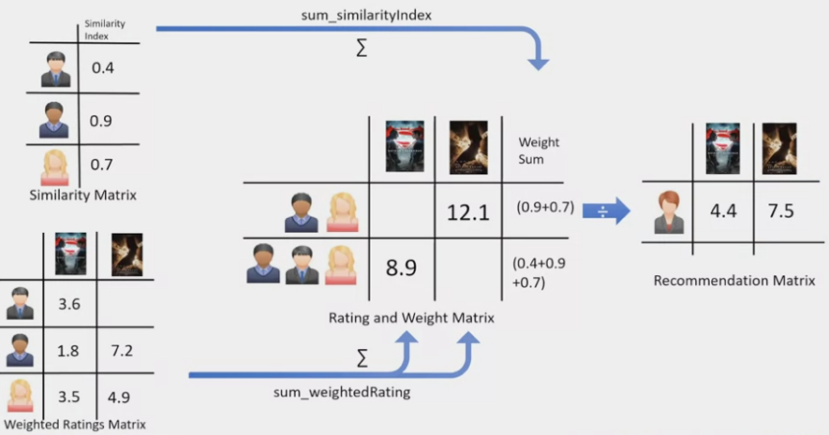

User-based

1. Based on users’ of the same neighborhood

Item-based

1. Based on the items and their ratings

Challenges

1. Data sparsity
   1. Users only rate a limited number of items
2. Cold start
   1. Difficulty in recommendation to new users or new items
3. Scalability
   1. Increase in number of users or items

